Learn to play the Bagpipes
With

The Boise Highlanders
Application deadline Oct 9, 2015
School begins Oct 20, 2015

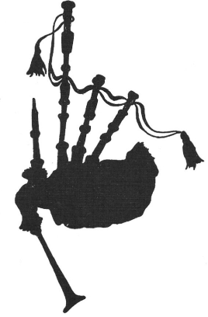

$150.00

Includes:
- Practice Chanter
- Bagpipe Tutor
- Flash Cards
- T-Shirt
- Lessons from Oct. 2014 through May 2015

Contact:

Ron or Joyce Lopez 362-3144
Joyce Lopez ghostpiper@hotmail.com
Ron Lopez thebigdrone@hotmail.com

Boise Highlanders’ Piping School
Registration Form 2015/2016

Date:
Name:
Address:

Phone No.
Email
Age

T-Shirt Size: Adult S M L XL XXL
Child S M L

Previous Piping Experience

Previous Music Experience

Why do you want to learn to play the bagpipes?

Signature
(Signature of guardian if applicant is a minor)
Because class size will be limited, a $50.00 non-refundable deposit (payable to the Boise Highlanders) must accompany this form to secure your place in the school by Oct 9, 2015. The remaining $100.00 is due the first night of class.

Send to: Joyce Lopez
9220 S. Talon Lane
Boise, ID 83709

