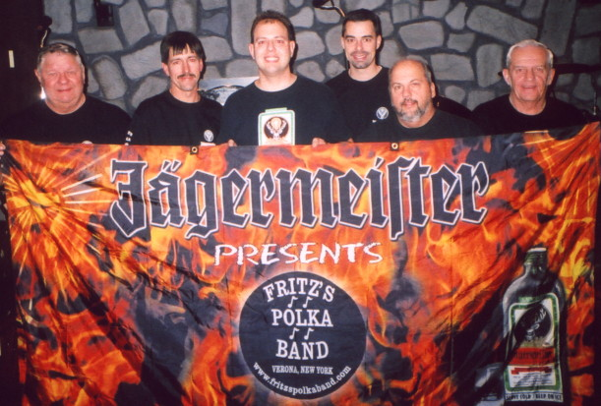
www.fritzspolkaband.com
www.fritzspolkaband.net
www.jagermusic.com

June 25, 2005: Utica Masonic Festival----------Utica, NY:
It was a hazy, hot, & humid day, with temperatures near triple digits. But, that didn’t stop FPB from cranking out some Verona-style in a fresh way. Of course, we just went through a lot more water! Here’s the list of tunes we did today:

1st set: Here Is Fritz’s Polka Band / Give Polka Music A Chance ’98, Green Grass Polka, Sailor, Fritz’s Waltz, FPB On Tap, Crying My Heart Out Over You, Blue Skirt Waltz (requested), Square Green Bottle, In Heaven There Is No Beer (requested), I Can’t Help It, Rautenberg’s Oberek (requested), Helena Polka (requested), Beer Barrel Polka (requested), Lay Down Beside Me, and Grandparent’s Polka.

MINI 2nd set (due to a karate demonstration and parade): Fire Up!, Memphis, and Havin’ Fun.

3rd set: Tick Tock Polka (requested), It’s 5 O’ Clock In The Morning (requested), Drive Me Crazy, Two Pina Coladas, Margaritaville, Please Don’t Wait ‘Til Tomorrow (new song!), Hey Little Sweetheart, Just Because Polka, I Stopped For A Beer, There’s A Tear In My Beer, Who Stole The Keeshka (requested), Skippy’s Polka (button-box tune), and Gabe’s Polka (button-box tune),

4th set: Old Habits, Scherz’s Polka, Old Flame, Golden Star Polka, Release Me, and All Night Long.

Next up, tomorrow we play for a private party, and then, it’s the FPB Fan Club Summer Picnic Party…and if you’re not in the FPB Fan Club, you’re gonna miss out big time!!!!!

