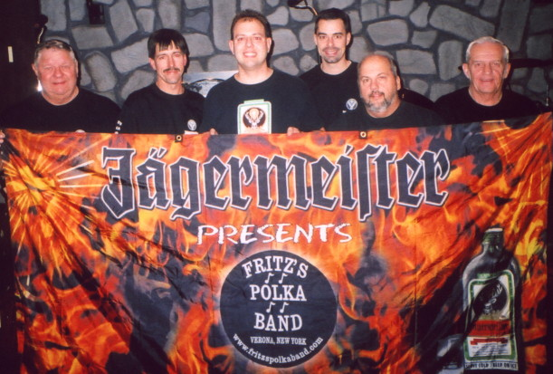
www.fritzspolkaband.com
www.fritzspolkaband.net
www.jagermusic.com
September 18, 2005: The Great Escape---Lake George, NY:
The weather was a bit nicer today, and there were quite a few more people at The Great Escape. Once again, we made some new friends, and had a great time. We’re certainly looking forward to performing here again next weekend! Here’s the list of tunes we did today:

1st set | 2nd set | 3rd set | 4th set
Here Is Fritz’s Polka Band / Can’t Get Enough Of Polka Music | Another Polka Dance | Mikey J’s Polka (button-box tune) | Happy Birthday (to Connor)
Apples, Peaches, Pumpkin Pie | South Euclid Polka | Tuffy’s Polka (button-box tune) | Long Live Polka
Frauline | Mountain Flower Waltz | Chime Bells (Tom solo) | Bubble’s Polka
Side By Side | Baby Doll Polka | Havin’ Fun | Jeanette’s Waltz
Make The World Go Away | Never On A Sunday | Kentucky Waltz | No Beer Today
In Heaven There Is No Beer | Have Another Beer | Boonville Polka | Today I Started Loving You Again
Green Grass Polka | Nobody’s Darling But Mine | Clarinet Polka | Just Because Polka
 | Real Good Time |  | Bye, Bye Baby
Next up, we play next weekend at The Great Escape, on Saturday and Sunday…………..

