REQUEST
Page 1 of 2 Today’s Date:

The following information is required to participate in the Healthy Living service, please make sure each section is completed:
Partner Organization Name: |  |  | Tribe Name:
Address: |  |  | Office Phone #:
City, State, Zip |  |  | Office Fax #:
Primary Contact: |  | Alternate Phone #:  (other than office number)
Title: |  | Email address:
Secondary Contact: |  | Alternate Phone #:  (other than office number)
Title: |  | Email address:
Is the storage location secure and lockable? ☐Yes ☐ No

Delivery Location (e.g. Senior Center): Dimension of Storage (e.g. 2 x 8): X
Physical Driving Directions:

Please list the goals of your organization (for example, PWNA’s Goal is “promote self-sufficiency on reservations”):
Goal 1:
Goal 2:

Please help PWNA to understand how the Healthy Living Service is going to help your organization achieve, or make progress towards, the goal(s) listed above. Select your top 2 answers:

☐ Increased Resources ☐ Increased Community Engagement ☐ Improved Outreach ☐ Improved Education
☐ Improved Health ☐ Improved Public Safety ☐ Improved Programing ☐Improved Results

Please explain how your 2 selections above will help you achieve your organizational goals:

How do you advertise your services, circle all that apply? ☐ Poster ☐ Social Media ☐ Radio ☐ Other:

What is the education provided to participant(s)?

Without duplicating, how many people are you planning to serve?
- Everyone that will receive products must place signature  on the participation log (sign out sheet) provided. | Kids  (0-10) | Youth (11-18) | Adults  (19-64) | Elders (65+) | Total
- Total number of signatures should be close to the number expected.
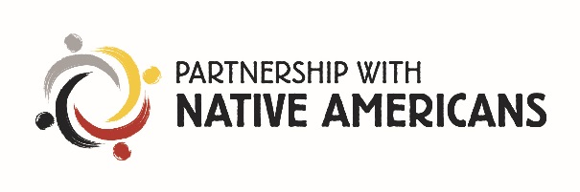
How does your program offer services? (Check All That Apply)
 | Frequency: Please Click | Location: Please Click
☐ One-on-One Education | ☐ Monthly ☐ Weekly ☐ Daily | ☐ on site ☐ other:
☐ Home Visits | ☐ Monthly ☐ Weekly ☐ Daily | ☐ on site ☐ other:
☐ Classes | ☐ Monthly ☐ Weekly ☐ Daily | ☐ on site ☐ other:

REQUEST
Page 2 of 2
Items requested:
Please place a check mark by the types of items that will best fit your program needs. PWNA will fill requests in accordance with the number of participants on your proposal request form and based on inventory available at the time of the request.

☐ Household/Cleaning Supplies ☐ Personal Care Items ☐ Food (non-perishable) ☐Drinks

☐Adult Diapers ☐ Children’s Diapers ☐ Other (please list items not included):

How many volunteers/staff have been recruited to assist your program?
TOTAL
- Are your volunteer’s staff members? ☐ Yes ☐ No

What kind of service does your Organization offer on a regular basis?

Where are you having difficulty with program attendance or program participation? Please explain

How will you distribute the incentives received by PWNA? Once a Month, Weekly, After Each Class, etc.?

Other Resources: As a reminder, PWNA is a supplementary service. Please list all other organizations supporting your program and the resources they will provide. Approval of your proposal is not contingent upon this information.
Program Partner Agreement
I guarantee that the products requested with this Healthy Living request will be used in the manner specified. Products provided by Partnership With Native Americans (PWNA) CANNOT be sold or distributed to promote any type of tribal business (i.e. elections, meetings, campaigns, etc.). If at any time, PWNA is informed that a Program Partner and/or program volunteers have used the products in such a manner, PWNA will be forced to drop the Program Partner.
I will provide a secure and safe storage facility. I will send a follow-up report of the program/event. I will educate a secondary contact on every aspect of my obligations so that in the event I cannot complete my agreement the secondary contact can.
Disclaimer: Products provided by National Relief Charities (NRC) CANNOT be sold or distributed to promote any type of Tribal business (i.e. elections, meetings, campaigns, etc.). If at any time, NRC is informed that a Program Partner and/or program volunteers have used the products in such manner, NRC will be forced to drop the Program Partner.
Program Partner Primary Contact Signature |  | Date

