REQUEST
Page 1 of 1 Today’s Date: _____________

The following information is required to participate in the New Baby Service, please make sure each section is completed:
Partner Organization Name: |  |  | Tribe Name:
Address: |  |  | Office Phone #:
City, State, Zip: |  |  | Office Fax #:
Primary Contact: |  | Alternate Phone #:  (other than office number)
Title: |  | Email address:
Secondary Contact: |  | Alternate Phone #:  (other than office number)
Title: |  | Email address:

Is the storage location secure and lockable? □ Yes □ No

Delivery Location (e.g. IHS hospital): Dimension of Storage (e.g. 2 x 8): X
Physical Driving Directions:

How will you advertise the New Baby Service? Poster Newspaper Radio Phone Other: _______________
(Please circle all that apply)
How many births were recorded in your community last year?________________________________________
How many prenatal mothers are you currently providing services for?__________________________________

Program Partner Agreement
I_____________________________ guarantee that the products requested with this New Baby Request will be used in the manner specified. Products provided by Partnership With Native Americans (PWNA) CANNOT be sold or distributed to promote any type of tribal business (i.e. elections, meetings, campaigns, etc.). If at any time, PWNA is informed that a Program Partner and/or program volunteers have used the products in such a manner, PWNA will be forced to drop the Program Partner.
I will provide a secure and safe storage facility. I will send a follow-up report of the program/event. I will educate a secondary contact on every aspect of my obligations so that in the event I cannot complete my agreement the secondary contact can.
Program Partner Primary Contact Signature |  | Date

How many baby immunizations did you give last year? _____________________________________________

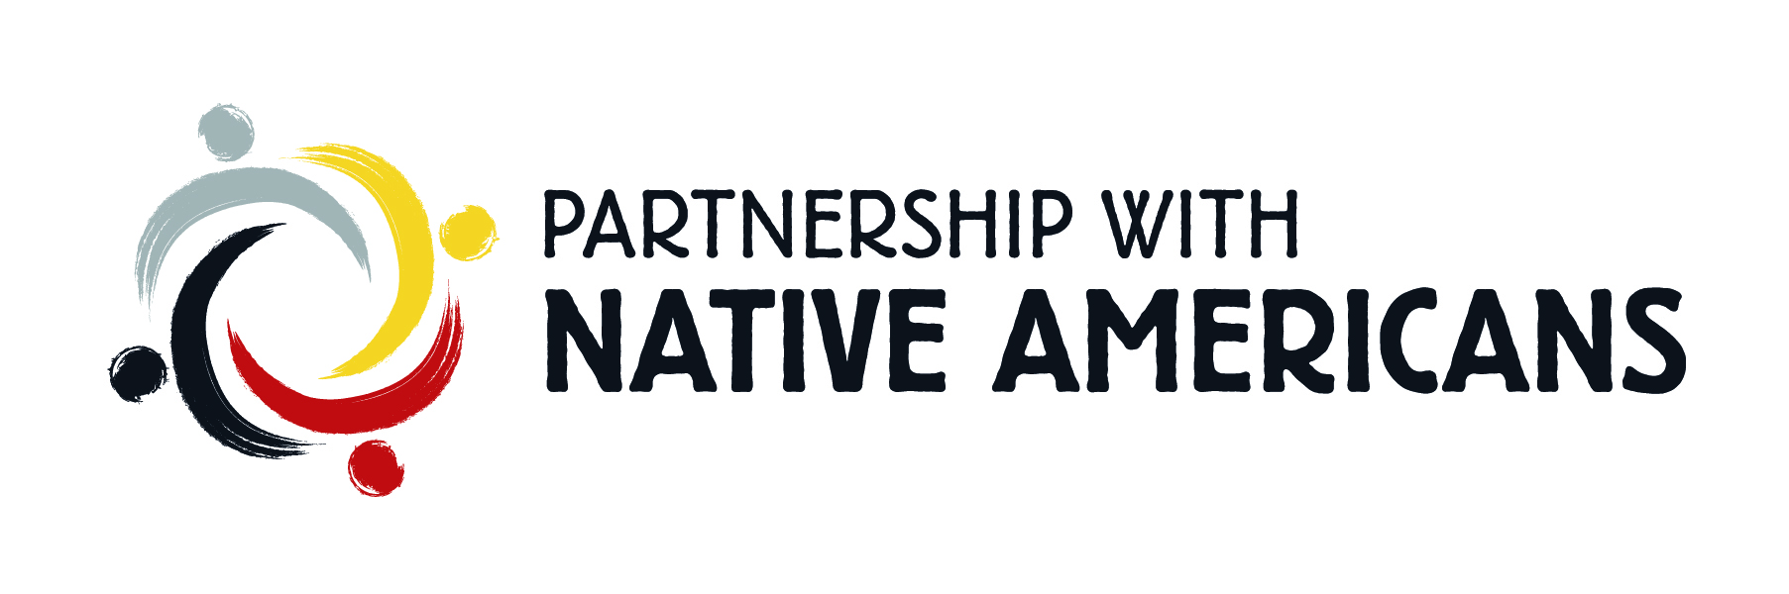

New Mommy Card
(New moms must attend a total of six (6) clinic appointments or classes to earn an extra incentive)

New Mommy Name: ___________________________ Program Organization Name: _____________________

Appointments or Classes | Signature or Stamp
 Date Attended: _____________ | __________________
 Date Attended: _____________ | __________________
 Date Attended: _____________ | __________________
 Date Attended: _____________ | __________________ Incentive Received:
 Date Attended: _____________ | __________________
 Date Attended: _____________ | __________________ __________________

____________________________________________ _______________________________
Program Partner Contact Signature Date

1310 E. Riverview Dr. Phoenix, AZ 85034
Tel: 602-340-8050 * Toll Free: 877-281-0808 * Fax: 602-340-8055

---------------------------------------------------------------Cut Here---------------------------------------------------------------------

New Baby

New Mommy Card
(New moms must attend a total of six (6) clinic appointments or classes to earn an extra incentive)

New Mommy Name: ___________________________ Program Organization Name: _____________________

Appointments or Classes | Signature or Stamp
 Date Attended: _____________ | __________________
 Date Attended: _____________ | __________________
 Date Attended: _____________ | __________________
 Date Attended: _____________ | __________________ Incentive Received:
 Date Attended: _____________ | __________________
 Date Attended: _____________ | __________________ __________________

____________________________________________ _______________________________
Program Partner Contact Signature Date

