REQUEST
Page 1 of 2
Today’s Date:
The following information is required to participate in the Residential Service. Please make sure each section is completed.
Partner Organization Name: |  |  | Tribe Name:
Address: |  |  | Office Phone #:
City, State, Zip: |  |  | Office Fax #:
Primary Contact: |  | Alternate Phone #:  (other than office number)
Title: |  | Email address:
Secondary Contact: |  | Alternate Phone #:  (other than office number)
Title: |  | Email address:

Is the storage location secure and lockable? ☐Yes ☐ No

Delivery Location (e.g. dorm): Dimension of Storage (e.g. 2 x 8): X
Physical Driving Directions:
Hours of operation: (for delivery purposes)

Please list the goals of your organization (for example, PWNA’s Goal is “promote self-sufficiency on reservations”):
Goal 1:
Goal 2:

Please help PWNA to understand how the Residential Service is going to help your organization achieve, or make progress towards, the goal(s) listed above. Select your top 2 answers:

☐ Increased Resources ☐ Increased Community Engagement ☐ Improved Outreach ☐ Improved Education
☐ Improved Health ☐ Improved Public Safety ☐ Improved Programing ☐Improved Results

Please explain how your 2 selections above will help you achieve your organizational goals:
Please describe the services your facility provides:

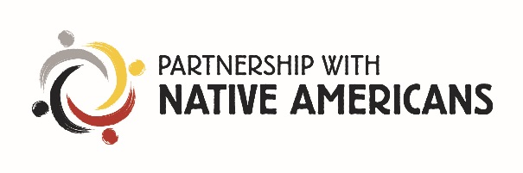
How would the Residential Service help your facility?
REQUEST
Page 2 of 2

How will you distribute the products received by PWNA?

Without duplicating, how many people are you planning to serve? | Men | Women | Children  (under 18) | Total
These numbers should represent your
monthly average census/count.

Men | Women | Children  (under 18)
What is the nightly capacity of your facility?
- These numbers should represent the maximum number of
residents your facility can house per night.

Average Length of Stay:

Items requested:
Please place a check mark by the types of items that will best fit your program needs. PWNA will fill requests in accordance with the number of participants on your proposal request form and based on inventory available at the time of the request.

☐ Cleaning/Laundry Supplies ☐ Bedding ☐ Personal Care items ☐ Food (non-perishable) ☐ Drink

☐ Clothing ☐ Shoes: (please click all that apply) ☐ Men’s ☐ Women’s ☐ Children’s

☐ Miscellaneous (Crafts, Accessories) ☐ Other (please list items not included):

Are there any product restrictions? (Examples: Products containing alcohol, sharp objects, and allergies)

Other Resources
As a reminder, PWNA is a supplementary service. Please list all other organizations supporting your program and the resources they will provide. Approval of your proposal is not contingent upon this information.

Program Partner Agreement
I guarantee that the products requested with this Residential Service Request will be used in the manner specified. Products provided by Partnership With Native Americans (PWNA) CANNOT be sold or distributed to promote any type of tribal business (i.e. elections, meetings, campaigns, etc.). If at any time, PWNA is informed that a Program Partner and/or program volunteers have used the products in such a manner, PWNA will be forced to drop the Program Partner.

I will provide a secure and safe storage facility. I will send a follow-up report of the program/event. I will educate a secondary contact on every aspect of my obligations so that in the event I cannot complete my agreement the secondary contact can.

Program Partner Primary Contact Signature |  | Date

